**BUSINESS REQUIREMENTS DOCUMENT**

**PROJECT NAME:**

**iDeposit – Create On-Call Order of CIT Service when AutoPickup Percentage is reached**

**TFS: 15492**

**REVISION NUMBER: 1.3**

|  |  |
| --- | --- |
| **Project Roles and Responsibilities** | |
| **Business Champion** | Brent Morris |
| **Project Requestor / Advocate** | Brent Morris |
| **Stakeholders** | Brent Morris |

Contents

1 Purpose 3

2 Business Design 3

3 Requirements 3

3.1 Requirements List 3

3.2 Screen Layouts or Prototypes 3

3.3 Report Layouts 4

4 Support Information 4

5 Revision History 5

6 Approvals 5

7 Approvals 5

# Purpose

The business would like to have the iDeposit system automatically generate a request for service for the next available service date if the total value of deposits created since the last service reaches a provided percentage of the maximum deposit value.

# Business Design

A new profile field will be created in iCash Cash Admin to provide a Maximum Deposit Threshold Percent value (AUTOPICKUP%) which will be used to determine when a service request should be generated automatically.

When an iDeposit is created, the total value of iDeposits with a pickup date greater than Day 2 plus the value of the new iDeposit ~~since last pickup cutoff time~~ will be calculated to determine if the Auto Pickup should be initiated.

# Requirements

# Requirements List

|  |  |
| --- | --- |
| **Req ID** | **Requirement Description** |
| **1.0** | **Calculate Deposit Percentage** |
| 1.1 | When a new iDeposit is created, calculate the total value of the newly created deposit plus all iDeposits ~~that have been created on the current business day. (Since last cutoff time)~~  with a pickup date greater than Day 2. (Day 2 = next business day) |
| 1.2 | Calculate the percentage of deposits to maxdepositvalue  (calculation - total of deposits /~~MAXDEPOSITVALUE~~ DAILYDEPOSITLIMIT |
| 1.3 | If % is >= AUTOPICKUP% then display a message “Your company requires armored service for the next available day when total deposits reach a specified value.  An armored service request will be automatically processed for your location for the next approved service day.  Should you have any questions or concerns, please contact your company representative. Please complete your deposit ticket creation.” and create a deposit for next available day. (follow the rules for generated deposits from 15367 |
| 1.4 | If Service Unit does not have a by ~~MAXDEPOSITVALUE~~ DAILYDEPOSITLIMIT or AUTOPICKUP% then default to $200,000 at 100% |
| 1.5 | Only valid for On-Call Customers |

## Screen Layouts or Prototypes

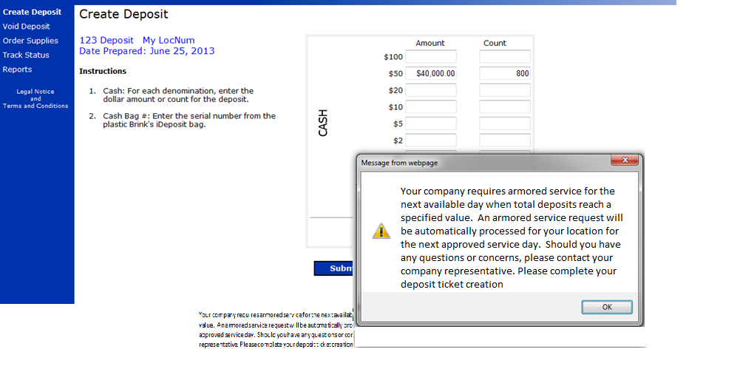

## Report Layouts

There are no reports.

# Support Information

* 1. **Assumptions**
* This work item will be completed in conjunction with work item 15367 – iDeposit On-Call Service
* This work item is dependent on work item 15507 - iCash CA - add Profile field for iDeposit AUTOPICKUP%
  1. **Exclusions**
* There are no known exclusions.
  1. **Systems Impacts**

|  |  |  |
| --- | --- | --- |
| **System** | **Impacted** | **Comments** |
| Currency Processing (CP) | No |  |
| Currency Admin (CA) | Yes | Profile fields are read |
| Coin | No |  |
| Oracle EBS | No |  |
| Safe Server | No |  |
| iInfo | No |  |
| iReports | No |  |
| iDeposit | Yes |  |
| iOrder | No |  |
| OrderAdmin | No |  |
| iProfile | No |  |
| iATM | No |  |
| BAMS | No |  |
| Extracts | No |  |
| iTrack | No |  |
| HEAT | No |  |
| People Soft | No |  |

# Revision History

|  |  |  |  |
| --- | --- | --- | --- |
| Revision Number | Revision Date | Author | Description of Change |
| 1.0 | 06/24/2013 | Russell Beard | Initial Document |
| 1.1 | 07/02/2013 | Russell Beard | Updated verbiage for popup |
| 1.2 | 08/13/2013 | Russell Beard | Updated calculation for threshold to be deposits created on a business day (since last cutoff) |
| 1.3 | 08/20/2013 | Russell Beard | Updated calculation to be new iDeposit plus all iDeposits with a pickup date greater than Day 2. (Day 2 is the next business day)  And to use the DAILYDEPOSITLIMIT instead of MAXDEPOSITVALUE |

# Approvals



# Appendix

* 1. **Scenarios for Calculating AutoPickup Date**

